1. D
2. 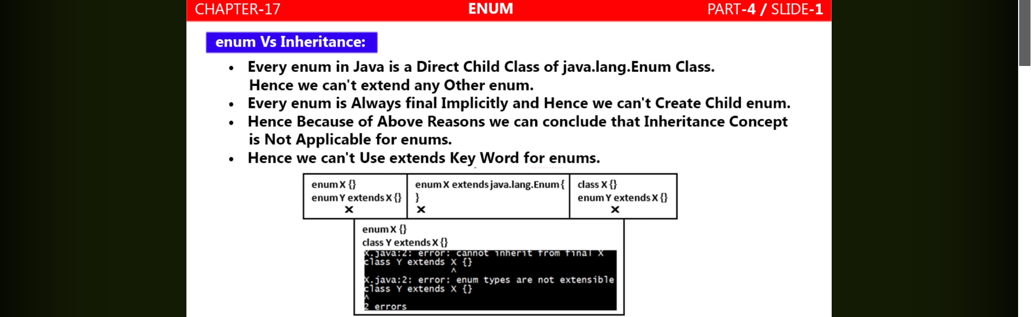
3. 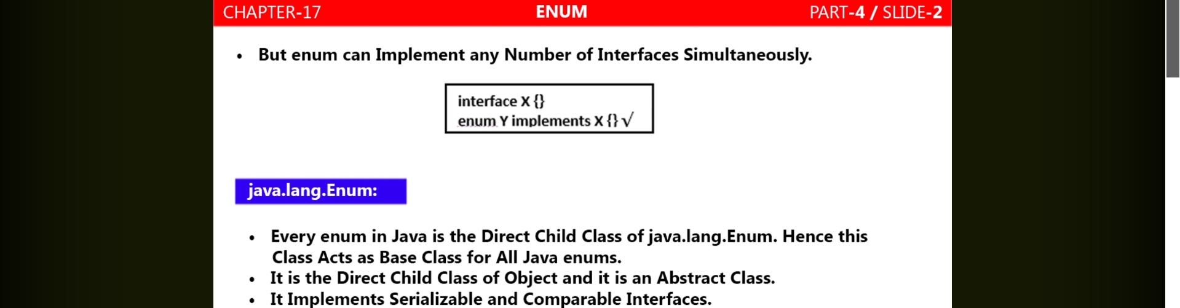
4. Like every java class is subclass of Object class directly or indirectly.   
   Similarly, every Enum is direct subtype of java.lang.Enum as indirect is not possible because sub-enum by us not possible because by default enum is final.
5. 
6. 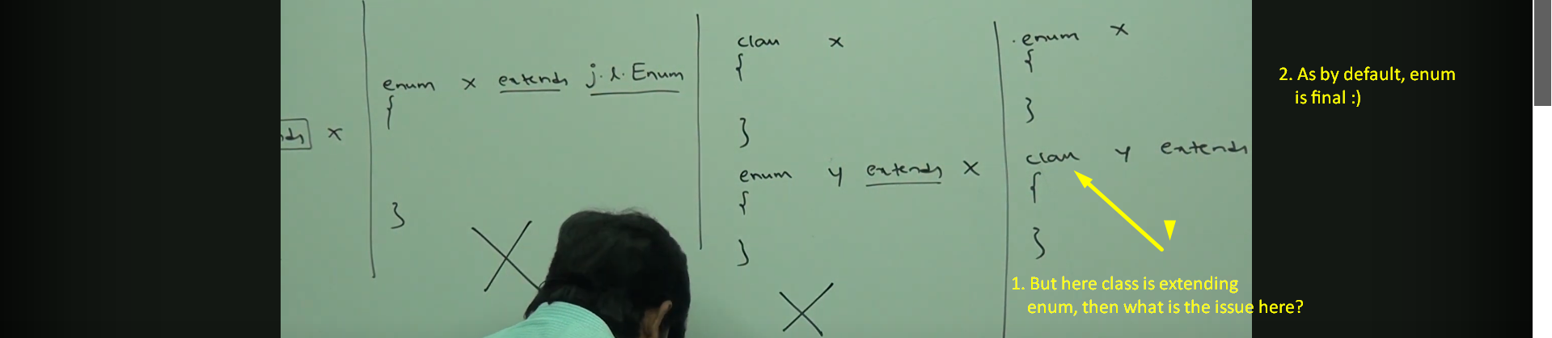
7. Enum can implement any number of interfaces.
   1. 